UNITED STATES
SECURITIES AND EXCHANGE COMMISSION
Washington, D.C. 20549

FORM 8-K

CURRENT REPORT

Pursuant to Section 13 or 15(d) of the Securities Exchange Act of 1934

Date of Report (Date of earliest event reported): September 8, 2026

Lifeward Ltd.

(Exact name of registrant as specified in its charter)

Israel |  | 001-36612 |  | Not applicable
(State or other jurisdiction of  incorporation or organization) |  | (Commission  File Number) |  | (IRS Employer  Identification No.)

2 Cabot Rd., Hudson, MA |  | 01749
(Address of principal executive offices) |  | (Zip Code)

Registrant’s telephone number, including area code: +508.251.1154

Not Applicable

(Former name or former address, if changed since last report)

Securities registered pursuant to Section 12(b) of the Exchange Act |  | Trading Symbol |  | Name of each exchange on which registered
Ordinary Shares, no par value |  | LFWD |  | Nasdaq Capital Market

Check the appropriate box below if the Form 8-K filing is intended to simultaneously satisfy the filing obligation of the registrant under any of the following provisions (see General Instruction A.2. below):

☐ | Written communications pursuant to Rule 425 under the Securities Act (17 CFR 230.425)

☐ | Soliciting material pursuant to Rule 14a-12 under the Exchange Act (17 CFR 240.14a-12)

☐ | Pre-commencement communications pursuant to Rule 14d-2(b) under the Exchange Act (17 CFR 240.14d-2(b))

☐ | Pre-commencement communications pursuant to Rule 13e-4(c) under the Exchange Act (17 CFR 240.13e-4(c))

Indicate by check mark whether the registrant is an emerging growth company as defined in Rule 405 of the Securities Act of 1933 (§230.405 of this chapter) or Rule 12b-2 of the Securities Exchange Act of 1934 (§240.12b-2 of this chapter).

Emerging growth company ☐

If an emerging growth company, indicate by check mark if the registrant has elected not to use the extended transition period for complying with any new or revised financial accounting standards provided pursuant to Section 13(a) of the Exchange Act. ☐

Item 7.01 Regulation FD Disclosure.

On September 8, 2026, the Lifeward Ltd. (the “Company”) posted to the “Investors” section of its website an investor presentation (the “Presentation”), which is furnished herewith as Exhibit 99.1. The Company intends to use the Presentation from time to time in making presentations to analysts, potential investors, and other interested parties.

Item 9.01 Financial Statements and Exhibits.

(d) Exhibits.

Exhibit No. |  | Description
99.1 |  | Investor Presentation dated September 8, 2026*
104 |  | Cover Page Interactive Data File (embedded within the Inline XBRL document)

*Furnished herewith

SIGNATURES

Pursuant to the requirements of the Securities Exchange Act of 1934, the Registrant has duly caused this report to be signed on its behalf by the undersigned hereunto duly authorized.

 | Lifeward Ltd.
Dated: September 8, 2026 | By: | /s/ Almog Adar
 | Name: | Almog Adar
 | Title: | Chief Financial Officer

Exhibit 99.1

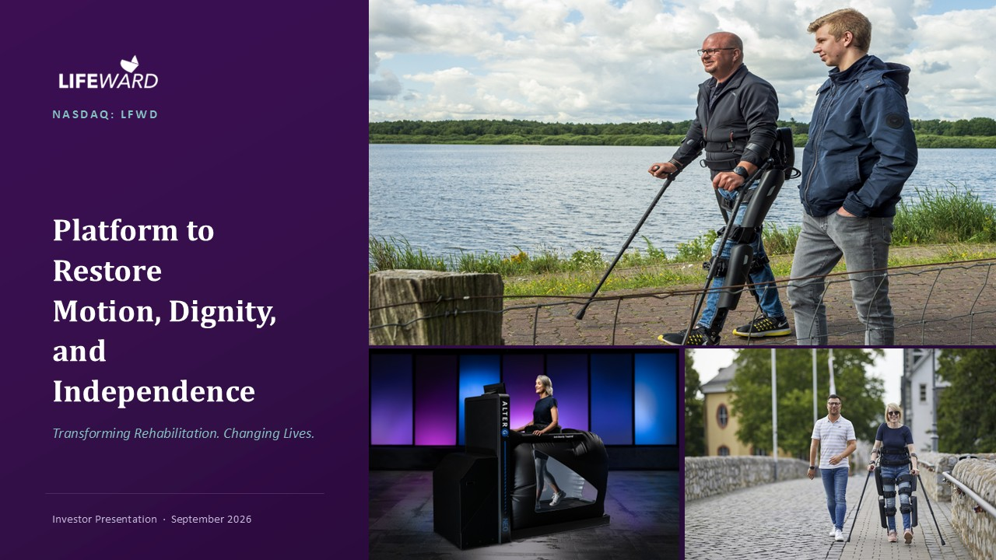
NASDAQ: LFWD Platform to Restore Motion, Dignity, and Independence Transforming Rehabilitation. Changing Lives. Investor Presentation · September 2026

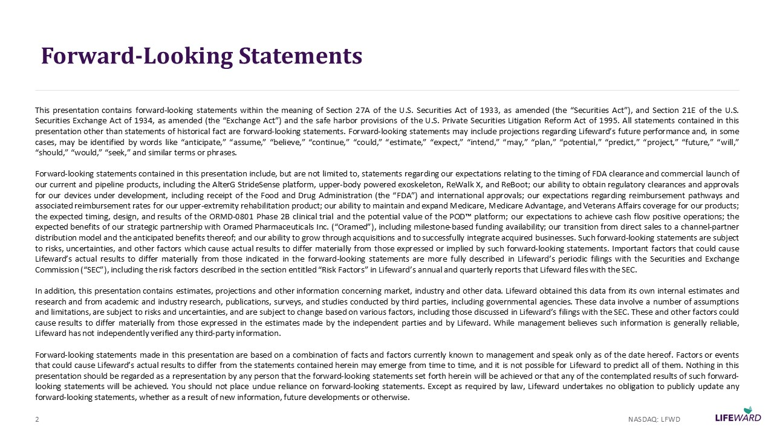
Forward - Looking Statements This presentation contains forward - looking statements within the meaning of Section 27 A of the U . S . Securities Act of 1933 , as amended (the “ Securities Act ” ), and Section 21 E of the U . S . Securities Exchange Act of 1934 , as amended (the “ Exchange Act ” ) and the safe harbor provisions of the U . S . Private Securities Litigation Reform Act of 1995 . All statements contained in this presentation other than statements of historical fact are forward - looking statements . Forward - looking statements may include projections regarding Lifeward ’ s future performance and, in some cases, may be identified by words like “ anticipate, ” “ assume, ” “ believe, ” “ continue, ” “ could, ” “ estimate, ” “ expect, ” “ intend, ” “ may, ” “ plan, ” “ potential, ” “ predict, ” “ project, ” “ future, ” “ will, ” “ should, ” “ would, ” “ seek, ” and similar terms or phrases . Forward - looking statements contained in this presentation include, but are not limited to, statements regarding our expectations relating to the timing of FDA clearance and commercial launch of our current and pipeline products, including the AlterG StrideSense platform, upper - body powered exoskeleton, ReWalk X, and ReBoot ; our ability to obtain regulatory clearances and approvals for our devices under development, including receipt of the Food and Drug Administration (the “ FDA ” ) and international approvals ; our expectations regarding reimbursement pathways and associated reimbursement rates for our upper - extremity rehabilitation product ; our ability to maintain and expand Medicare, Medicare Advantage, and Veterans Affairs coverage for our products ; the expected timing, design, and results of the ORMD - 0801 Phase 2 B clinical trial and the potential value of the POD platform ; our expectations to achieve cash flow positive operations ; the expected benefits of our strategic partnership with Oramed Pharmaceuticals Inc . ( “ Oramed ” ), including milestone - based funding availability ; our transition from direct sales to a channel - partner distribution model and the anticipated benefits thereof ; and our ability to grow through acquisitions and to successfully integrate acquired businesses . Such forward - looking statements are subject to risks, uncertainties, and other factors which cause actual results to differ materially from those expressed or implied by such forward - looking statements . Important factors that could cause Lifeward ’ s actual results to differ materially from those indicated in the forward - looking statements are more fully described in Lifeward ’ s periodic filings with the Securities and Exchange Commission ( “ SEC ” ), including the risk factors described in the section entitled “ Risk Factors ” in Lifeward ’ s annual and quarterly reports that Lifeward files with the SEC . In addition, this presentation contains estimates, projections and other information concerning market, industry and other data . Lifeward obtained this data from its own internal estimates and research and from academic and industry research, publications, surveys, and studies conducted by third parties, including governmental agencies . These data involve a number of assumptions and limitations, are subject to risks and uncertainties, and are subject to change based on various factors, including those discussed in Lifeward ’ s filings with the SEC . These and other factors could cause results to differ materially from those expressed in the estimates made by the independent parties and by Lifeward . While management believes such information is generally reliable, Lifeward has not independently verified any third - party information . Forward - looking statements made in this presentation are based on a combination of facts and factors currently known to management and speak only as of the date hereof . Factors or events that could cause Lifeward ’ s actual results to differ from the statements contained herein may emerge from time to time, and it is not possible for Lifeward to predict all of them . Nothing in this presentation should be regarded as a representation by any person that the forward - looking statements set forth herein will be achieved or that any of the contemplated results of such forward - looking statements will be achieved . You should not place undue reliance on forward - looking statements . Except as required by law, Lifeward undertakes no obligation to publicly update any forward - looking statements, whether as a result of new information, future developments or otherwise . 2 NASDAQ: LFWD

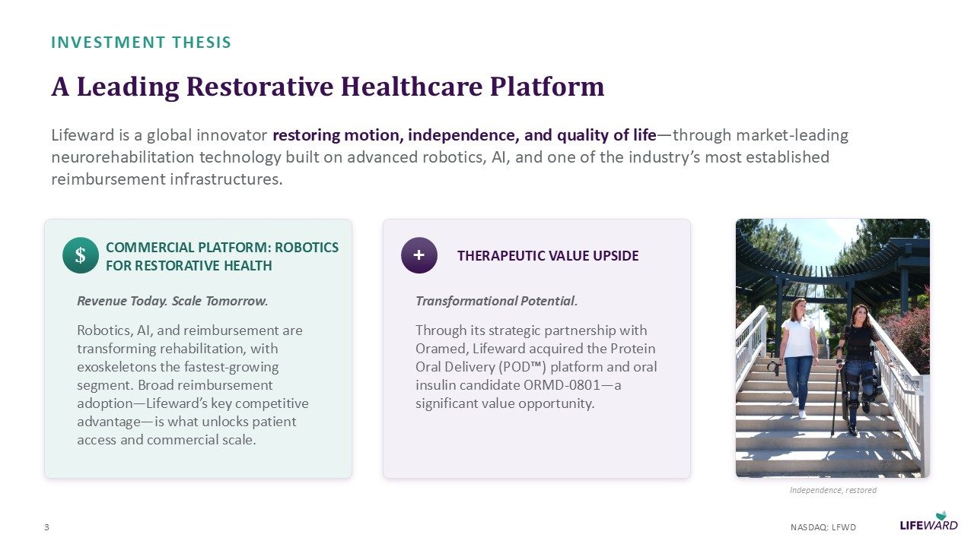
INVESTMENT THESIS A Leading Restorative Healthcare Platform Lifeward is a global innovator restoring motion, independence, and quality of life — through market - leading neurorehabilitation technology built on advanced robotics, AI, and one of the industry ’ s most established reimbursement infrastructures. $ COMMERCIAL PLATFORM: ROBOTICS FOR RESTORATIVE HEALTH Revenue Today. Scale Tomorrow. Robotics, AI, and reimbursement are transforming rehabilitation, with exoskeletons the fastest - growing segment. Broad reimbursement adoption — Lifeward ’ s key competitive advantage — is what unlocks patient access and commercial scale. + THERAPEUTIC VALUE UPSIDE Transformational Potential. Through its strategic partnership with Oramed, Lifeward acquired the Protein Oral Delivery (POD ) platform and oral insulin candidate ORMD - 0801 — a significant value opportunity. 3 Independence, restored NASDAQ: LFWD

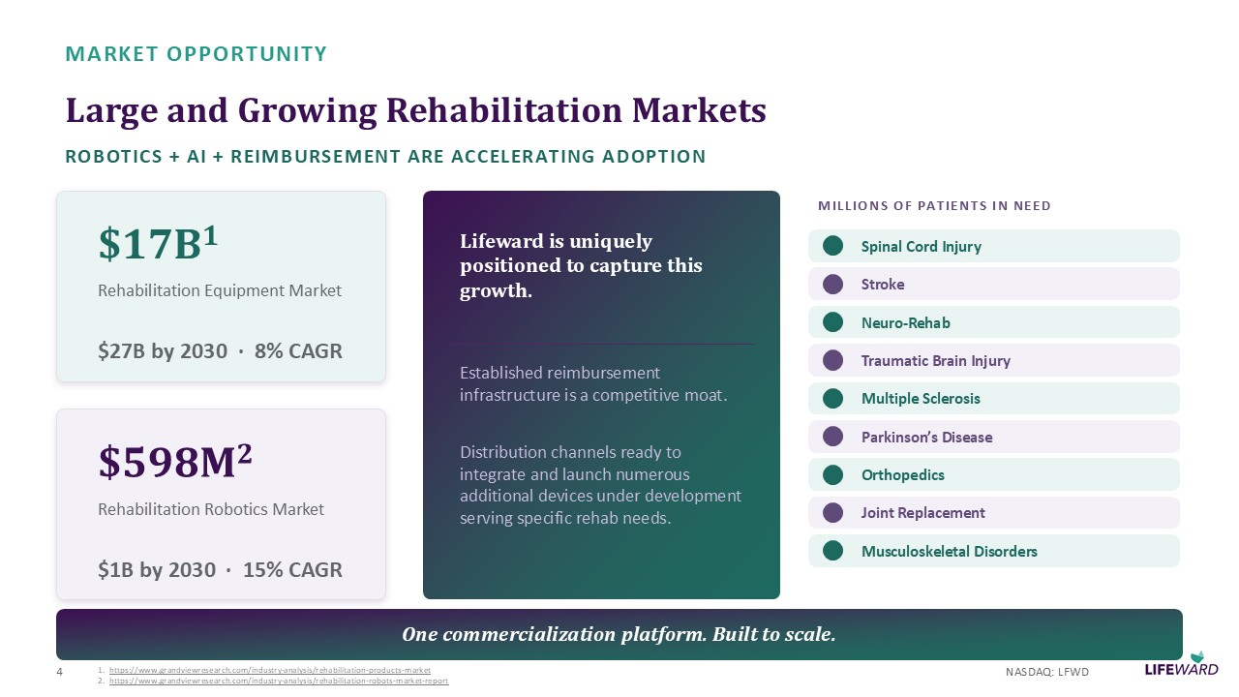
MARKET OPPORTUNITY Large and Growing Rehabilitation Markets ROBOTICS + AI + REIMBURSEMENT ARE ACCELERATING ADOPTION $ 17 B 1 Rehabilitation Equipment Market $ 27 B by 2030 · 8 % CAGR $ 598 M 2 Rehabilitation Robotics Market $ 1 B by 2030 · 15 % CAGR Lifeward is uniquely positioned to capture this growth . Established reimbursement infrastructure is a competitive moat. Distribution channels ready to integrate and launch numerous additional devices under development serving specific rehab needs. MILLIONS OF PATIENTS IN NEED Spinal Cord Injury Stroke Neuro - Rehab Traumatic Brain Injury Multiple Sclerosis Parkinson ’ s Disease Orthopedics Joint Replacement Musculoskeletal Disorders One commercialization platform. Built to scale. 4 NASDAQ: LFWD 1. https://www.grandviewresearch.com/industry - analysis/rehabilitation - products - market 2. https://www.grandviewresearch.com/industry - analysis/rehabilitation - robots - market - report

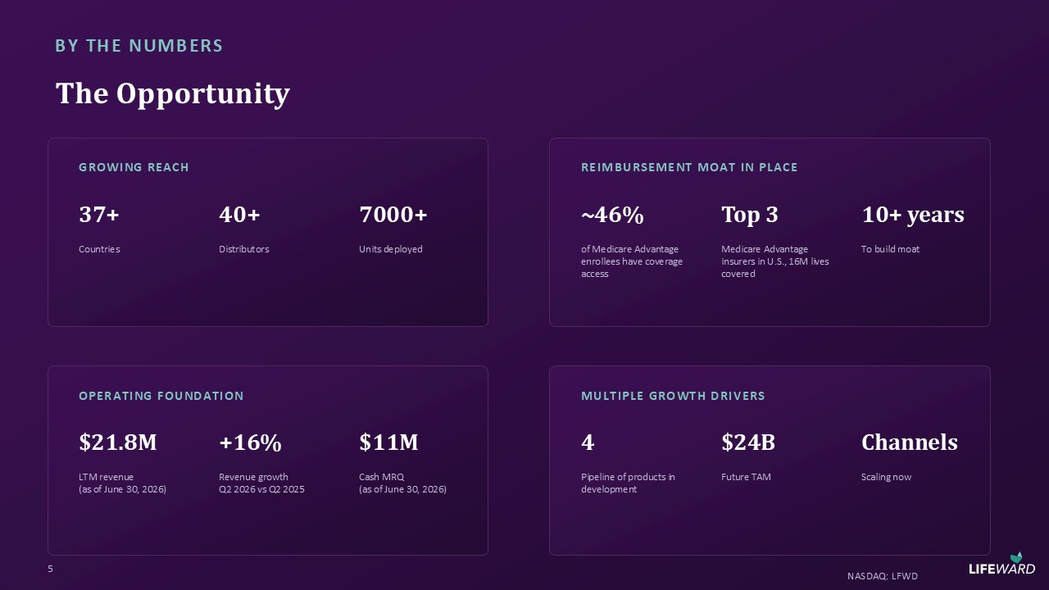
BY THE NUMBERS The Opportunity GROWING REACH 37 + Countries 40 + Distributors 7000 + Units deployed REIMBURSEMENT MOAT IN PLACE ~ 46 % of Medicare Advantage enrollees have coverage access Top 3 Medicare Advantage insurers in U.S., 16 M lives covered 10 + years To build moat OPERATING FOUNDATION $ 21.8 M LTM revenue (as of June 30 , 2026 ) + 16 % Revenue growth Q 2 2026 vs Q 2 2025 $ 11 M Cash MRQ ( as of June 30 , 2026 ) MULTIPLE GROWTH DRIVERS 4 Pipeline of products in development $ 24 B Future TAM Channels Scaling now 5 NASDAQ: LFWD

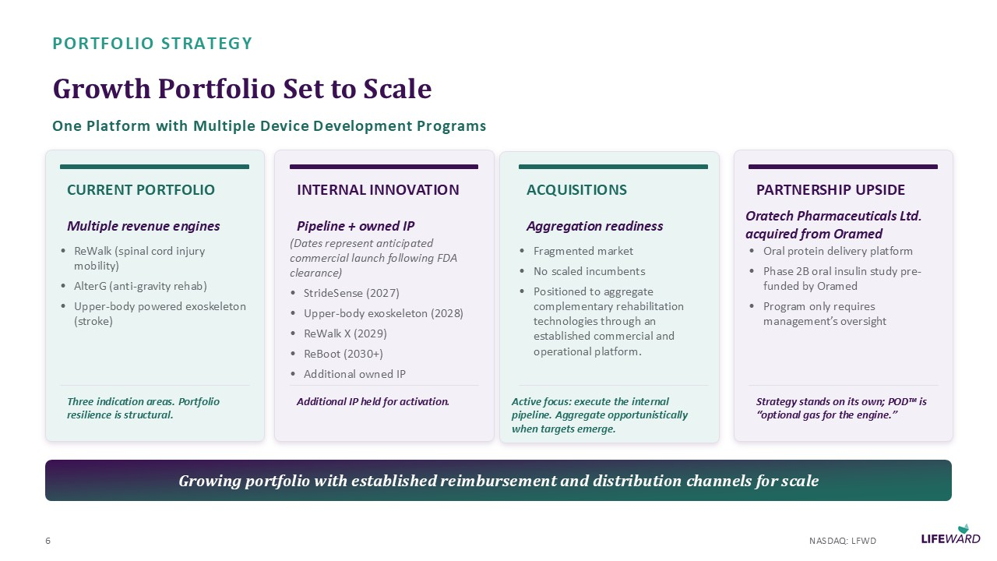
PORTFOLIO STRATEGY Growth Portfolio Set to Scale One Platform with Multiple Device Development Programs CURRENT PORTFOLIO Multiple revenue engines • ReWalk (spinal cord injury mobility) • AlterG (anti - gravity rehab) • Upper - body powered exoskeleton (stroke) Three indication areas. Portfolio resilience is structural. INTERNAL INNOVATION Pipeline + owned IP (Dates represent anticipated commercial launch following FDA clearance) • StrideSense ( 2027 ) • Upper - body exoskeleton ( 2028 ) • ReWalk X ( 2029 ) • ReBoot ( 2030 +) • Additional owned IP Additional IP held for activation . ACQUISITIONS Aggregation readiness • Fragmented market • No scaled incumbents • Positioned to aggregate complementary rehabilitation technologies through an established commercial and operational platform. Active focus: execute the internal pipeline. Aggregate opportunistically when targets emerge. PARTNERSHIP UPSIDE Oratech Pharmaceuticals Ltd. acquired from Oramed • Oral protein delivery platform • Phase 2 B oral insulin study pre - funded by Oramed • Program only requires management ’ s oversight Strategy stands on its own; POD is “ optional gas for the engine. ” Growing portfolio with established reimbursement and distribution channels for scale 6 NASDAQ: LFWD

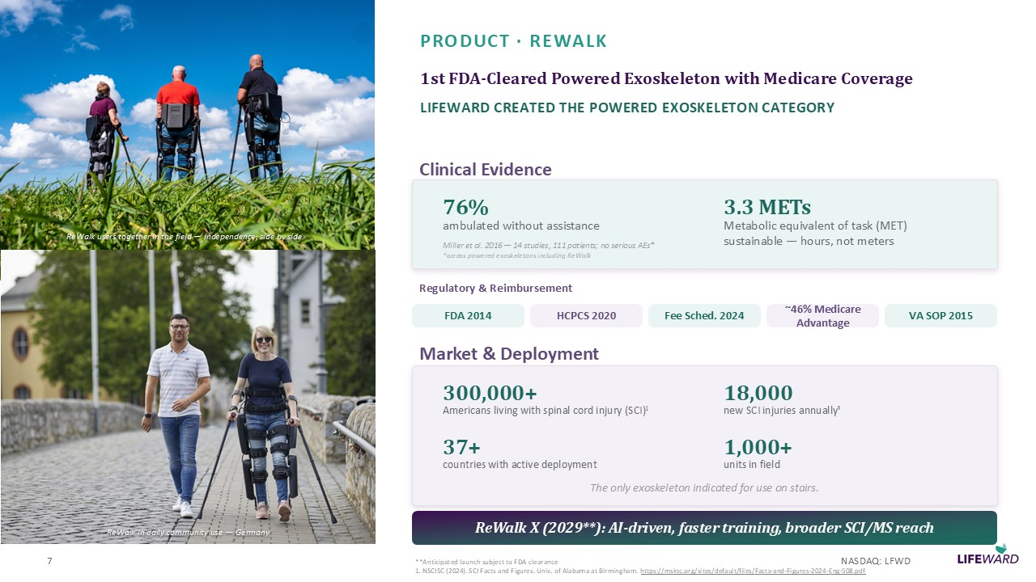
ReWalk users together in the field — independence, side by side ReWalk in daily community use — Germany PRODUCT · REWALK 1 st FDA - Cleared Powered Exoskeleton with Medicare Coverage LIFEWARD CREATED THE POWERED EXOSKELETON CATEGORY Clinical Evidence 76 % ambulated without assistance 3.3 METs Metabolic equivalent of task (MET) sustainable — hours, not meters Miller et al. 2016 — 14 studies, 111 patients; no serious AEs* *across powered exoskeletons including ReWalk Regulatory & Reimbursement FDA 2014 HCPCS 2020 Fee Sched. 2024 ~ 46 % Medicare Advantage VA SOP 2015 Market & Deployment 300,000 + Americans living with spinal cord injury (SCI) 1 18,000 new SCI injuries annually ¹ 37 + countries with active deployment 1,000 + units in field The only exoskeleton indicated for use on stairs. ReWalk X ( 2029 **): AI - driven, faster training, broader SCI/MS reach 7 **Anticipated launch subject to FDA clearance 1 . NSCISC ( 2024 ). SCI Facts and Figures. Univ. of Alabama at Birmingham. https://msktc.org/sites/default/files/Facts - and - Figures - 2024 - Eng - 508 .pdf NASDAQ: LFWD

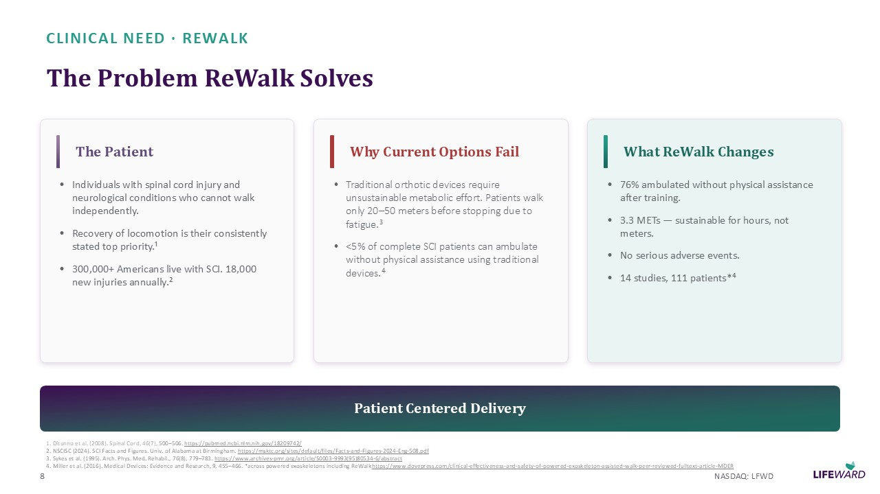
CLINICAL NEED · REWALK The Problem ReWalk Solves The Patient • Individuals with spinal cord injury and neurological conditions who cannot walk independently. • Recovery of locomotion is their consistently stated top priority. ¹ • 300,000 + Americans live with SCI. 18,000 new injuries annually. ² Why Current Options Fail • Traditional orthotic devices require unsustainable metabolic effort. Patients walk only 20 – 50 meters before stopping due to fatigue. ³ • < 5 % of complete SCI patients can ambulate without physical assistance using traditional devices. ⁴ What ReWalk Changes • 76 % ambulated without physical assistance after training. • 3.3 METs — sustainable for hours, not meters. • No serious adverse events. • 14 studies, 111 patients* ⁴ Patient Centered Delivery 1 . Ditunno et al. ( 2008 ). Spinal Cord, 46 ( 7 ), 500 – 506 . https://pubmed.ncbi.nlm.nih.gov/ 18209742 / 2 . NSCISC ( 2024 ). SCI Facts and Figures. Univ. of Alabama at Birmingham. https://msktc.org/sites/default/files/Facts - and - Figures - 2024 - Eng - 508 .pdf 3 . Sykes et al. ( 1995 ). Arch. Phys. Med. Rehabil., 76 ( 8 ), 779 – 783 . https://www.archives - pmr.org/article/S 0003 - 9993 ( 95 ) 80534 - 6 /abstract 4 . Miller et al. ( 2016 ). Medical Devices: Evidence and Research, 9 , 455 – 466 . *across powered exoskeletons including ReWalk https://www.dovepress.com/clinical - effectiveness - and - safety - of - powered - exoskeleton - assisted - walk - peer - reviewed - fulltext - article - MDER 8 NASDAQ: LFWD

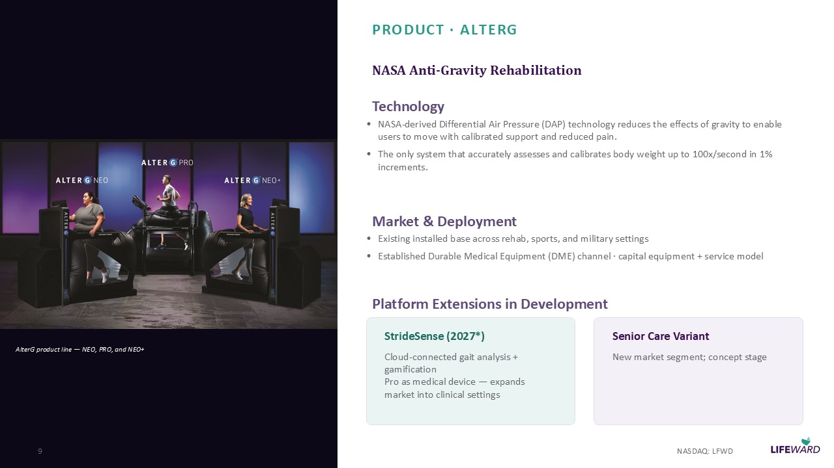
AlterG product line — NEO, PRO, and NEO+ PRODUCT · ALTERG NASA Anti - Gravity Rehabilitation Technology • NASA - derived Differential Air Pressure (DAP) technology reduces the effects of gravity to enable users to move with calibrated support and reduced pain. • The only system that accurately assesses and calibrates body weight up to 100 x/second in 1 % increments. Market & Deployment • Existing installed base across rehab, sports, and military settings • Established Durable Medical Equipment (DME) channel · capital equipment + service model Platform Extensions in Development StrideSense ( 2027 *) Cloud - connected gait analysis + gamification Pro as medical device — expands market into clinical settings Senior Care Variant New market segment; concept stage 9 NASDAQ: LFWD *Anticipated launch subject to FDA clearance

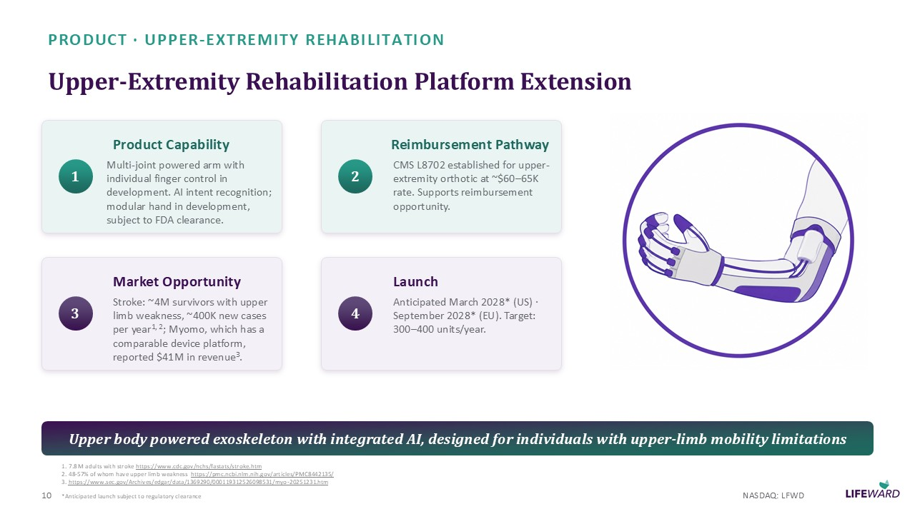
PRODUCT · UPPER - EXTREMITY REHABILITATION Upper - Extremity Rehabilitation Platform Extension 1 Product Capability Multi - joint powered arm with individual finger control in development. AI intent recognition; modular hand in development, subject to FDA clearance. 2 Reimbursement Pathway CMS L 8702 established for upper - extremity orthotic at ~$ 60 – 65 K rate. Supports reimbursement opportunity. 3 Market Opportunity Stroke: ~ 4 M survivors with upper limb weakness, ~ 400 K new cases per year 1 , 2 ; Myomo, which has a comparable device platform, reported $ 41 M in revenue 3 . 4 Launch Anticipated March 2028 * (US) · September 2028 * (EU). Target: 300 – 400 units/year. Upper body powered exoskeleton with integrated AI, designed for individuals with upper - limb mobility limitations 10 NASDAQ: LFWD *Anticipated launch subject to regulatory clearance 1 . 7.8 M adults with stroke https://www.cdc.gov/nchs/fastats/stroke.htm 2 . 48 - 57 % of whom have upper limb weakness https://pmc.ncbi.nlm.nih.gov/articles/PMC 8442135 / 3 . https://www.sec.gov/Archives/edgar/data/ 1369290 / 000119312526098531 /myo - 20251231 .htm

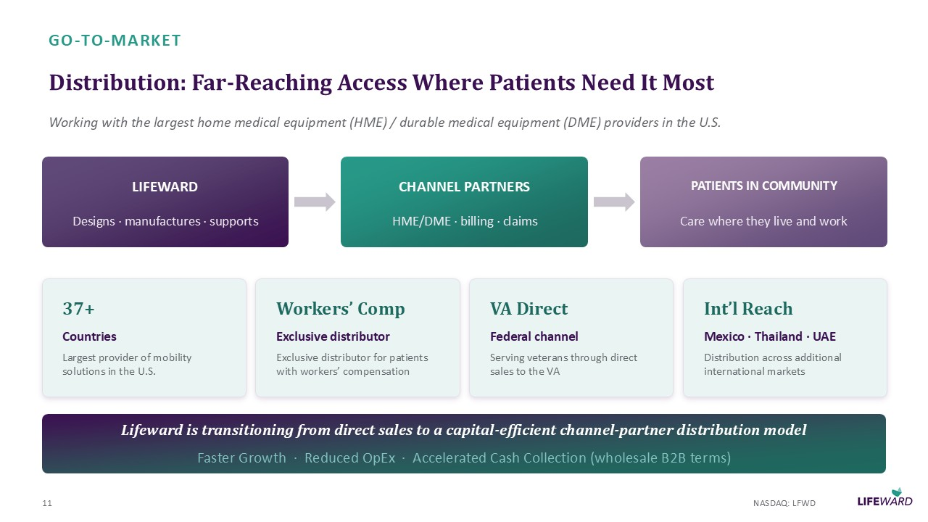
GO - TO - MARKET Distribution: Far - Reaching Access Where Patients Need It Most Working with the largest home medical equipment (HME) / durable medical equipment (DME) providers in the U.S. LIFEWARD Designs · manufactures · supports CHANNEL PARTNERS HME/DME · billing · claims PATIENTS IN COMMUNITY Care where they live and work 37 + Countries Largest provider of mobility solutions in the U.S. Workers ’ Comp Exclusive distributor Exclusive distributor for patients with workers ’ compensation VA Direct Federal channel Serving veterans through direct sales to the VA Int ’ l Reach Mexico · Thailand · UAE Distribution across additional international markets Lifeward is transitioning from direct sales to a capital - efficient channel - partner distribution model Faster Growth · Reduced OpEx · Accelerated Cash Collection (wholesale B 2 B terms) 11 NASDAQ: LFWD

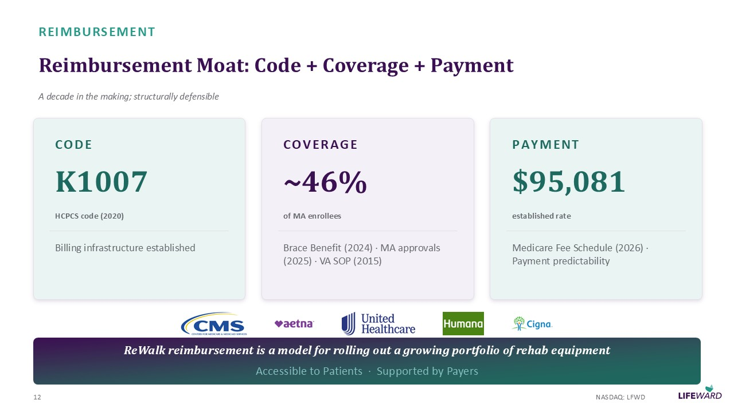
REIMBURSEMENT Reimbursement Moat: Code + Coverage + Payment A decade in the making; structurally defensible CODE K 1007 HCPCS code ( 2020 ) Billing infrastructure established COVERAGE ~ 46 % of MA enrollees Brace Benefit ( 2024 ) · MA approvals ( 2025 ) · VA SOP ( 2015 ) PAYMENT $ 95,081 established rate Medicare Fee Schedule ( 2026 ) · Payment predictability ReWalk reimbursement is a model for rolling out a growing portfolio of rehab equipment Accessible to Patients · Supported by Payers 12 NASDAQ: LFWD

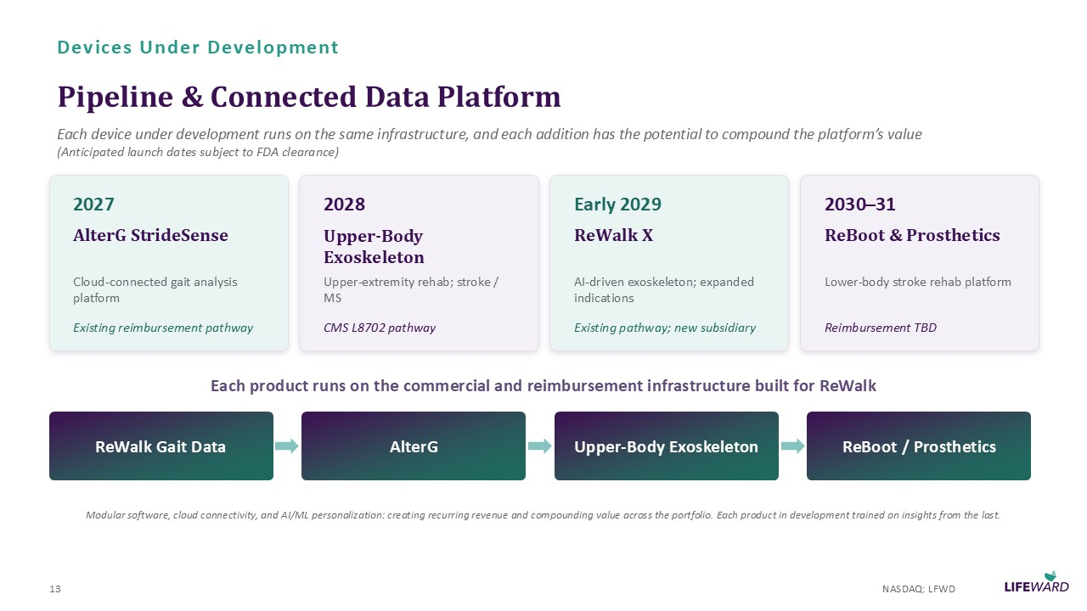
Devices Under Development Pipeline & Connected Data Platform Each device under development runs on the same infrastructure, and each addition has the potential to compound the platform ’ s value (Anticipated launch dates subject to FDA clearance) 2027 AlterG StrideSense Cloud - connected gait analysis platform Existing reimbursement pathway 2028 Upper - Body Exoskeleton Upper - extremity rehab; stroke / MS CMS L 8702 pathway Early 2029 ReWalk X AI - driven exoskeleton; expanded indications Existing pathway; new subsidiary 2030 – 31 ReBoot & Prosthetics Lower - body stroke rehab platform Reimbursement TBD Each product runs on the commercial and reimbursement infrastructure built for ReWalk ReWalk Gait Data AlterG Upper - Body Exoskeleton ReBoot / Prosthetics Modular software, cloud connectivity, and AI/ML personalization: creating recurring revenue and compounding value across the por tfolio. Each product in development trained on insights from the last. 13 NASDAQ: LFWD

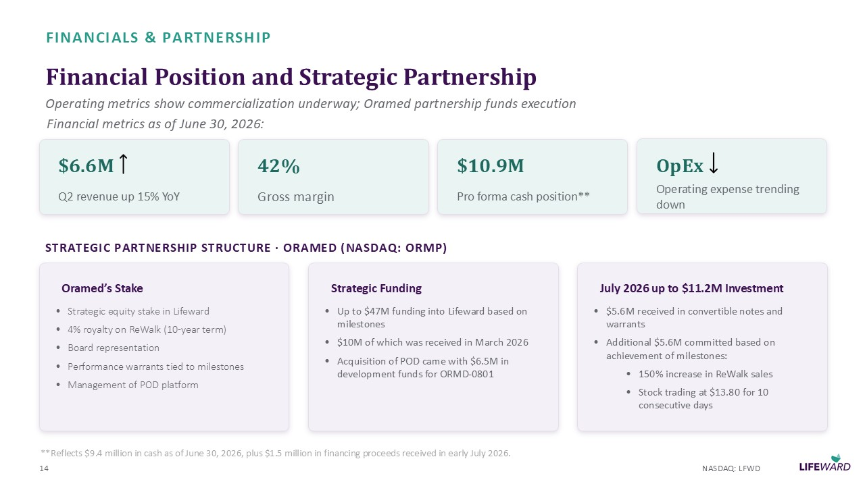
FINANCIALS & PARTNERSHIP Financial Position and Strategic Partnership Operating metrics show commercialization underway; Oramed partnership funds execution $ 6.6 M Q 2 revenue up 15 % YoY 42 % Gross margin $ 10.9 M Pro forma cash position** OpEx Operating expense trending down STRATEGIC PARTNERSHIP STRUCTURE · ORAMED (NASDAQ: ORMP) Oramed ’ s Stake • Strategic equity stake in Lifeward • 4 % royalty on ReWalk ( 10 - year term) • Board representation • Performance warrants tied to milestones • Management of POD platform Strategic Funding • Up to $ 47 M funding into Lifeward based on milestones • $ 10 M of which was received in March 2026 • Acquisition of POD came with $ 6.5 M in development funds for ORMD - 0801 July 2026 up to $ 11.2 M Investment • $ 5.6 M received in convertible notes and warrants • Additional $ 5.6 M committed based on achievement of milestones: • 150 % increase in ReWalk sales • Stock trading at $ 13.80 for 10 consecutive days 14 NASDAQ: LFWD Financial metrics as of June 30 , 2026 : **Reflects $ 9.4 million in cash as of June 30 , 2026 , plus $ 1.5 million in financing proceeds received in early July 2026 .

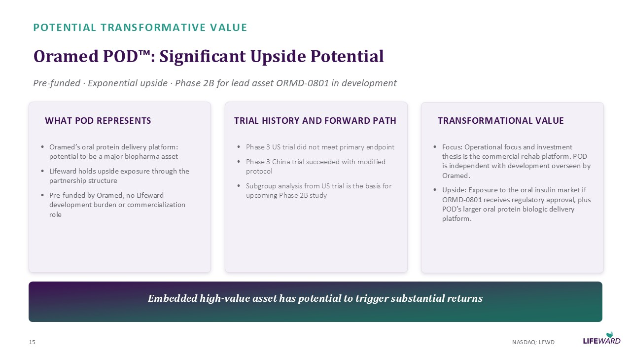
POTENTIAL TRANSFORMATIVE VALUE Oramed POD : Significant Upside Potential Pre - funded · Exponential upside · Phase 2 B for lead asset ORMD - 0801 in development WHAT POD REPRESENTS • Oramed ’ s oral protein delivery platform: potential to be a major biopharma asset • Lifeward holds upside exposure through the partnership structure • Pre - funded by Oramed, no Lifeward development burden or commercialization role TRIAL HISTORY AND FORWARD PATH • Phase 3 US trial did not meet primary endpoint • Phase 3 China trial succeeded with modified protocol • Subgroup analysis from US trial is the basis for upcoming Phase 2 B study TRANSFORMATIONAL VALUE • Focus: Operational focus and investment thesis is the commercial rehab platform. POD is independent with development overseen by Oramed. • Upside: Exposure to the oral insulin market if ORMD - 0801 receives regulatory approval, plus POD ’ s larger oral protein biologic delivery platform. Embedded high - value asset has potential to trigger substantial returns 15 NASDAQ: LFWD

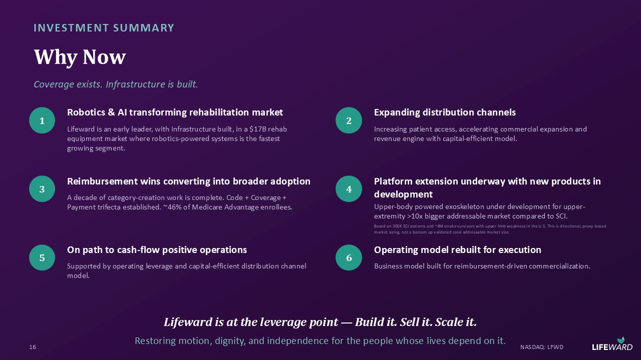
INVESTMENT SUMMARY Why Now Coverage exists. Infrastructure is built. 1 Robotics & AI transforming rehabilitation market Lifeward is an early leader, with infrastructure built, in a $ 17 B rehab equipment market where robotics - powered systems is the fastest growing segment. 2 Expanding distribution channels Increasing patient access, accelerating commercial expansion and revenue engine with capital - efficient model. 3 Reimbursement wins converting into broader adoption A decade of category - creation work is complete. Code + Coverage + Payment trifecta established. ~ 46 % of Medicare Advantage enrollees. 4 Platform extension underway with new products in development Upper - body powered exoskeleton under development for upper - extremity > 10 x bigger addressable market compared to SCI. Based on 300 K SCI patients and ~ 4 M stroke survivors with upper limb weakness in the U.S. This is directional, proxy - based market sizing, not a bottom up validated total addressable market size. 5 On path to cash - flow positive operations Supported by operating leverage and capital - efficient distribution channel model. 6 Operating model rebuilt for execution Business model built for reimbursement - driven commercialization. Lifeward is at the leverage point — Build it. Sell it. Scale it. Restoring motion, dignity, and independence for the people whose lives depend on it. 16 NASDAQ: LFWD

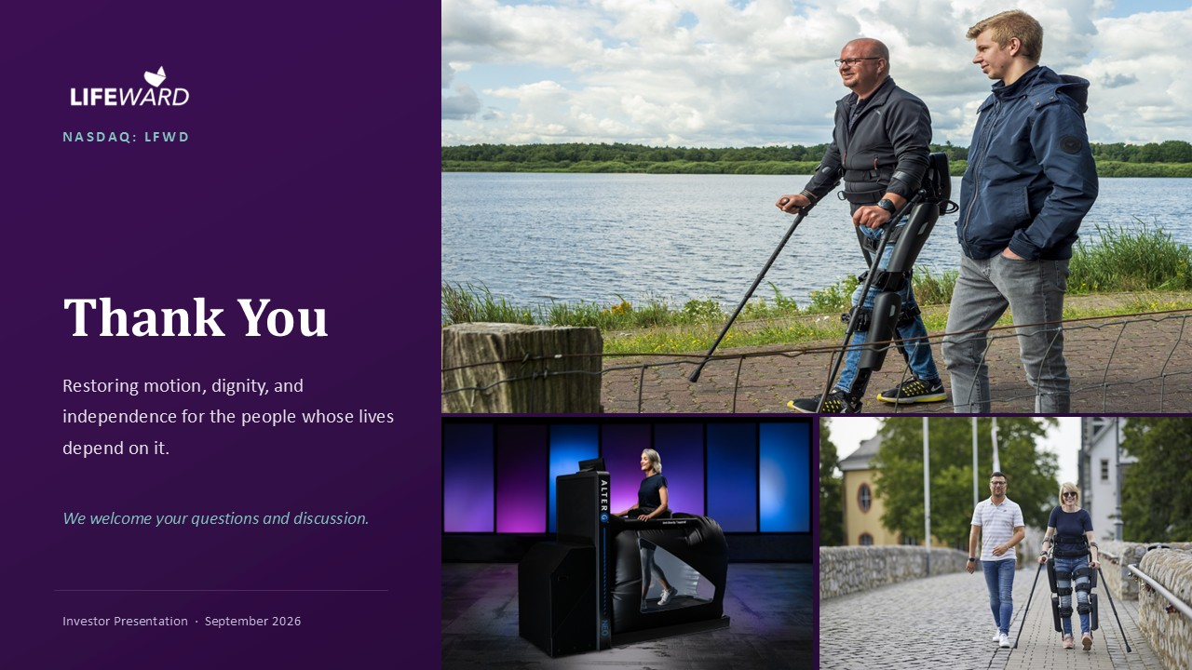
NASDAQ: LFWD Thank You Restoring motion, dignity, and independence for the people whose lives depend on it. We welcome your questions and discussion. Investor Presentation · September 2026

